Solar Tracking System

Introduction

The power generated from solar panels cannot be directly used in many applications. One of the key reasons is that the sun is not stationary as it keeps moving from east to west. The solar panels are able to receive peak sunlight only for a short time period of the day when the sun is directly facing the solar panels. During rest of the day, they get only partial
sunlight. To address this problem, here is a sun tracker device that allows the solar panel to track the sun’s position, ensuring maximum power generation.

Block Diagram
Solar Panel

Stepper Motor Driver Module
Stepper Motor
Arduino Uno
(Microcontroller Unit)
LDR Module 1
LDR Module 2

Working principle

The block diagram of the sun tracker with position display is shown in above Fig.

The 2 LDR modules read the light intensity from the Sun Rays and provide feedback to the Arduino Controller unit.

The C program running inside the Arduino will get the values from the LDR modules and calculate the angle to turn in the Left or Right direction.

The direction will be decided based on the intensity of light falling on the two LDR modules.

Once the Direction to turn is decided the Arduino will give command to Stepper motor driver module to turn the stepper motor in particular direction in calculated angle.

The Solar Panel is mounted on the Stepper motor which will turn towards the direction of sun, when the stepper motor rotates.
When the Solar panel is facing directly in direction of the sun the system will stop unless there is further change in the Sun’s position.

Components Used

- Arduino Uno – Atmega Microcontroller
- LDR Modules
- Stepper motor driver module (L293D IC)
- Stepper motor
- Solar Panel (3W small size)
- Resistors
- Capacitors
- LED
- Wires
- Diodes
- Connectors
- 7805 voltage regulator
- PCB
- Battery/ Power Supply
- Other discrete components.

Software

The software for this project will be written in C on Arduino IDE.

Mounting the solar panel

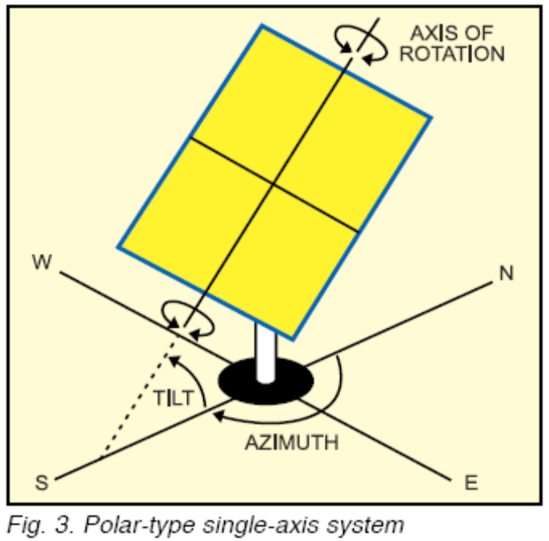

The panel is mounted on a single axis system. It is called a single-axis tracker as the mechanism rotates in only one plane around a single axis. The axis can be oriented such that the panels stand up at a tilt (called a polar axis) or lie flat (called a horizontal axis). Horizontal axis is more suitable for small latitudes (locations in the tropics and closer to the equator, i.e., southern India), whilst polar axis is more suitable for larger latitudes (locations far from the equator, i.e., northern India). This system tracks the sun from east to west during the day. The project described is a polar-type single-axis tracking system as shown in Fig.

Description of major components

Arduino UNO

Arduino is a single-board microcontroller, intended to make it easier to build interactive objects or environments. The hardware consists of an open-source hardware board designed around an 8-bit Atmel AVR microcontroller, or a 32-bit Atmel ARM. Current models feature a USB interface, 6 analog input pins, as well as 14 digital I/O pins that accommodate various extension boards.

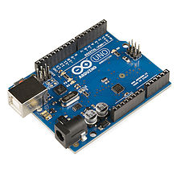

Stepper Motor

A Stepper Motor or a step motor is a brushless, synchronous motor which divides a full rotation into a number of steps. Unlike a brushless DC motor which rotates continuously when a fixed DC voltage is applied to it, a step motor rotates in discrete step angles. The Stepper Motors therefore are manufactured with steps per revolution of 12, 24, 72, 144, 180, and 200, resulting in stepping angles of 30, 15, 5, 2.5, 2, and 1.8 degrees per step. The stepper motor can be controlled with or without feedback.

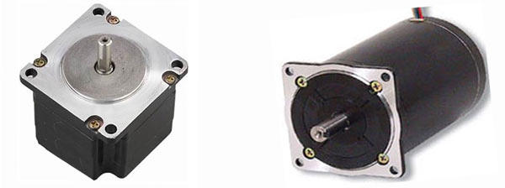

Motor Driver Module

Motor Driver ICs are primarily used in autonomous projects only. Also most microprocessors operate at low voltages and require a small amount of current to operate while the motors require a relatively higher voltages and current. Thus current cannot be supplied to the motors from the microprocessor. This is the primary need for the motor driver IC.
The L293D is a 16 pin IC, with eight pins, on each side, dedicated to the controlling of a motor. There are 2 INPUT pins, 2 OUTPUT pins and 1 ENABLE pin for each motor. L293D consist of two H-bridge. H-bridge is the simplest circuit for controlling a low current rated motor.

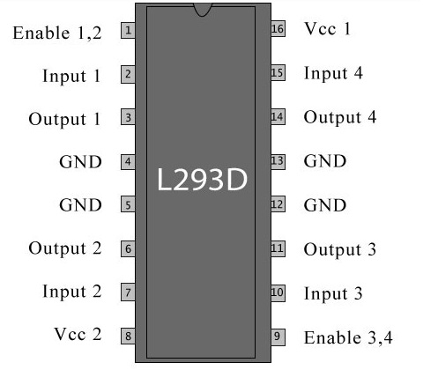

Solar Panel

Solar panel refers either to a photovoltaic module, a solar thermal energy panel, or to a set of solar photovoltaic (PV) modules electrically connected and mounted on a supporting structure. A PV module is a packaged, connected assembly of solar cells. Solar panels can be used as a component of a larger photovoltaic system to generate and supply electricity in commercial and residential applications. Each module is rated by its DC output power under standard test conditions, and typically ranges from 1W to 320 watts. The efficiency of a module determines the area of a module given the same rated output - an 8% efficient 230 watt module will have twice the area of a 16% efficient 230 watt module. There are a few solar panels available that are exceeding 19% efficiency. A single solar module can produce only a limited amount of power; most installations contain multiple modules. A photovoltaic system typically includes a panel or an array of solar modules, aninverter, and sometimes battery and/or solar tracker and interconnection wiring.

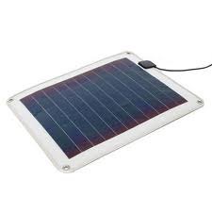
LDR

LDRs or Light Dependent Resistors are very useful especially in light/dark sensor circuits. Normally the resistance of an LDR is very high, sometimes as high as 1000 000 ohms, but when they are illuminated with light resistance drops dramatically.
As its name implies, the Light Dependent Resistor (LDR) is made from a piece of exposed semiconductor material such as cadmium sulphide that changes its electrical resistance from several thousand Ohms in the dark to only a few hundred Ohms when light falls upon it by creating hole-electron pairs in the material.
The net effect is an improvement in its conductivity with a decrease in resistance for an increase in illumination. Also, photoresistive cells have a long response time requiring many seconds to respond to a change in the light intensity.
Materials used as the semiconductor substrate include, lead sulphide (PbS), lead selenide (PbSe), indium antimonide (InSb) which detect light in the infra-red range with the most commonly used of all photoresistive light sensors beingCadmium Sulphide (Cds).
Cadmium sulphide is used in the manufacture of photoconductive cells because its spectral response curve closely matches that of the human eye and can even be controlled using a simple torch as a light source. Typically then, it has a peak sensitivity wavelength (λp) of about 560nm to 600nm in the visible spectral range.

